Code 1:

Question :  
 Given an array of integers nums and an integer target, return *indices of the two numbers such that they add up to target*.

You may assume that each input would have ***exactly* one solution**, and you may not use the *same* element twice.

You can return the answer in any order.

**Example 1:**

**Input:** nums = [2,7,11,15], target = 9

**Output:** [0,1]

**Explanation:** Because nums[0] + nums[1] == 9, we return [0, 1].

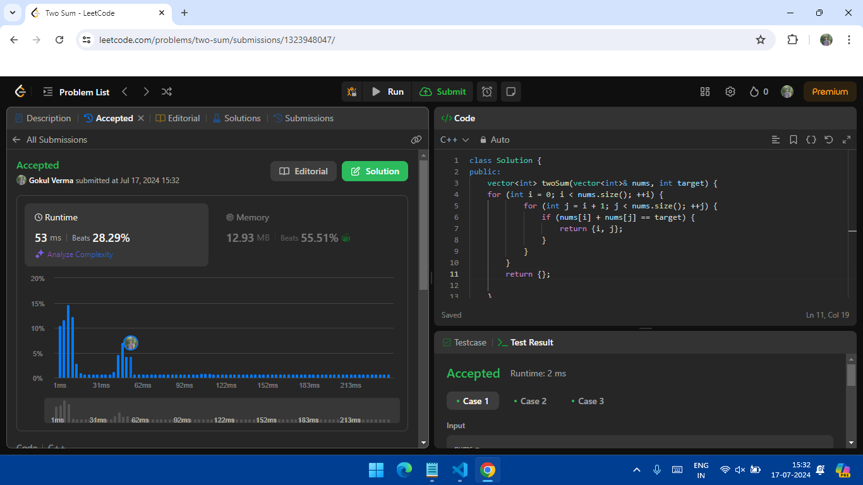Solution:

Code 2:

Given a string s containing just the characters '(', ')', '{', '}', '[' and ']', determine if the input string is valid.

An input string is valid if:

1. Open brackets must be closed by the same type of brackets.
2. Open brackets must be closed in the correct order.
3. Every close bracket has a corresponding open bracket of the same type.

**Example 1:**

**Input:** s = "()"

**Output:** true

Solution: 